Solution: Detail Views

In this lab, you will create a reusable Detail View Panel. Next, you will cut and paste widgets from an existing PCF file that you modified in a previous lab to your new file. You will then reference your detail view panel in various PCF files.

Requirements

This lab requires that you use TrainingApp 8.0, Guidewire Studio 8.0, and a supported web browser. To view, edit, and delete various contacts, log in to TrainingApp as Alice Applegate. The default URL for TrainingApp is <http://localhost:8880/ab/ContactManager.do>. The login/password for Alice Applegate is aapplegate/gw.

1. Create a Detail View Panel

In this exercise, you will create a PCF file for a detail view panel. Next, you will move the widgets from the Atomic Widgets lab into the new detail view panel. Then, you will add your detail view panel to the Analysis page.

Part A

In Part A of this exercise, you will create the ABContactAnalysisDV PCF File.

Configuration

1. Open Guidewire Studio for TrainingApp
2. From Studio, restart the server using Debug 'Server'.
3. Review the Debug console for errors.
4. Verify that the application is running in the Debug console.
5. Create the traininglabs PCF Folder
6. In the Project View, select the pcf folder.
7. Create a new PCF Folder named traininglabs (one word, no spaces).   
     
   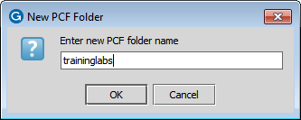
8. Create the ABContactAnalysisDV PCF file
9. Create the detail view panel PCF in the traininglabs PCF folder.  
   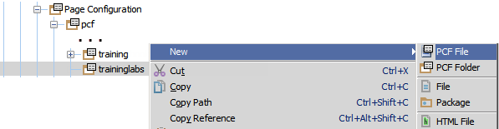  
   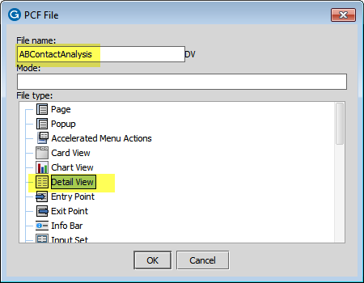
10. Specify a root object of the type ABContact.  
    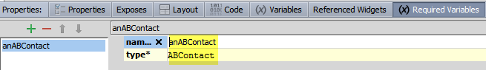

Part B

In a previous exercise, you created the contact analysis related widgets. In Part B of this exercise, you will cut and paste widgets from ABContactSummaryDV to ABContactAnalysisDV. By the end of Part B, you should no longer have any contact analysis related widgets in ABContactSummaryDV.

Configuration

1. Add an input column to ABContactAnalysisDV
2. Add an InputColumn widget to the detail view panel.  
   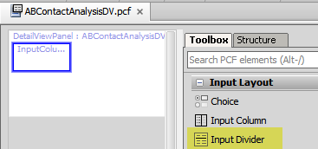
3. Navigate to ABContactSummaryDV
4. In the canvas, hide included sections.
5. Cut and paste widgets
6. Delete the InputDivider widget – specify which InputDivider?
7. Cut and paste the following widgets from the ABContactSummaryDV to ABContactAnalysisDV:
   * Contact Analysis label
   * Contact Tier input widget
   * Customer Rating input widget
   * Strategic Partner input widget
   * Last Courtesy Contact input widget
   * Fraud Investigations input widget
   * Web Address input widget

For each widget, copy the widget from ABContactSummaryDV, cut it in ABContactAnalysisDV, and click the intended location for the widget. (Contact Analysis widget is shown below as an example)

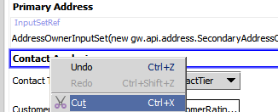

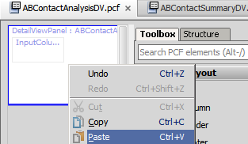

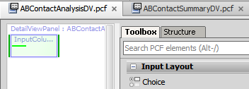

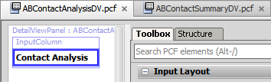

Part C

In Part C of this exercise, you will add the ABContactAnalysisDV to the ABContactAnalysisPage file.

Configuration

1. Navigate to ABContactAnalysisPage
2. In the canvas, hide included sections.
3. Delete the existing DetailViewPanel widget
4. In the canvas, delete the existing detail view panel.   
   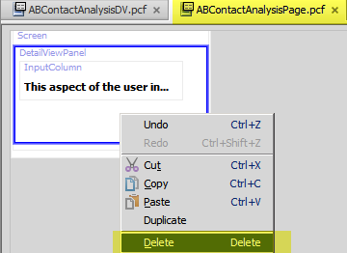
5. Add a PanelRef widget
6. In the Toolbox, select the PanelRef widget.
7. Add the Panel Ref widget to the ABContactAnalysisPage. 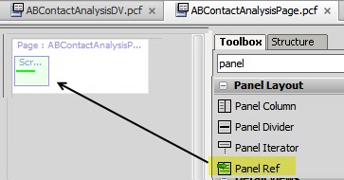
8. Configure the PanelRef widget
9. Reference the ABContactAnalysisDV in the Panel Ref.  
   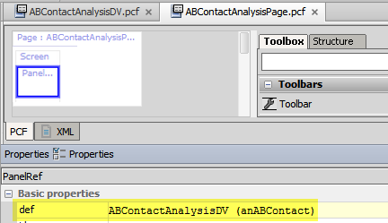
10. In the canvas, show included sections.

Part D

In Part D of this exercise, you will add the ABContactAnalysisDV to both the ABContactDetailsCV.ABCompany and ABContactDetailsCV.ABPerson files.

Configuration

1. Navigate to ABContactDetailsCV.ABCompany
2. In the canvas, hide included sections.
3. Select the Analysis card.
4. In the Analysis card canvas, delete the existing detail view panel.  
   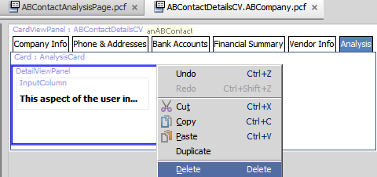
5. Add the ABContactAnalysisDV to the Analysis card.  
   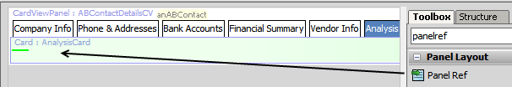

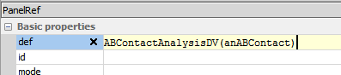

1. In the canvas, show included sections.
2. Navigate to ABContactDetailsCV.ABPerson
3. Select the Analysis card.
4. In the Analysis card canvas, delete the existing detail view panel.
5. Add the ABContactAnalysisDV to the Analysis card.  
   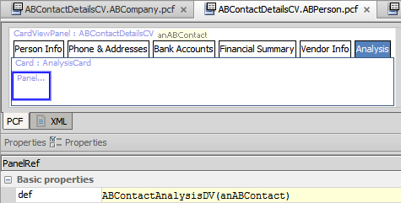

Verification

1. Log in to TrainingApp
2. Log in as Alice Applegate.
3. Reload the PCF changes
4. In TrainingApp, reload the changes to the PCF file(s).
5. View the Analysis card for William Andy
6. Search for William Andy.
7. In the search results list view, navigate to the William Andy contact.
8. In the sidebar menu, click Details.
9. Click the Analysis card tab.
10. Verify that you see the Contact Analysis detail view panel.

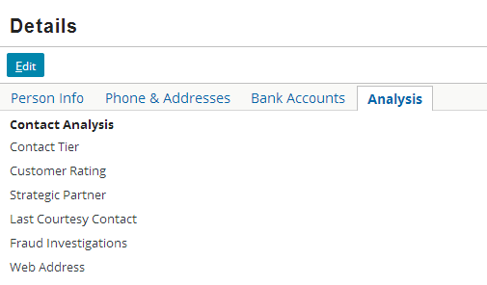

1. View the Analysis card for Burlingame Saab
2. Search for Burlingame Saab.
3. In the search results list view, navigate to the Burlingame Saab contact.
4. In the sidebar menu, click Details.
5. Click the Analysis card tab.
6. Verify that you see the Contact Analysis detail view panel.

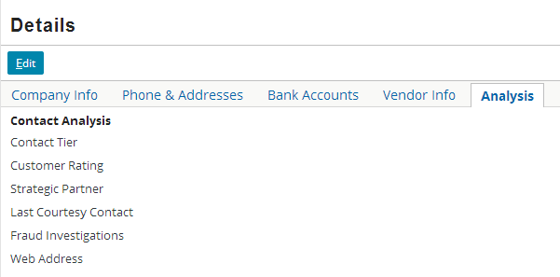

1. View the Analysis page for Burlingame Saab
2. In the sidebar menu, click Analysis.
3. Verify that you see the Contact Analysis detail view panel.

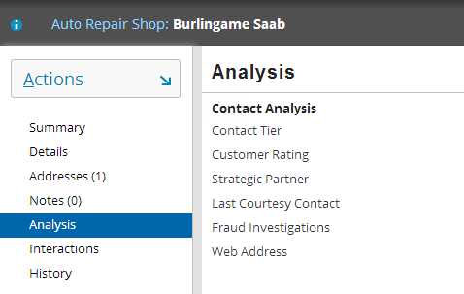

|  |  |
| --- | --- |
|  | Stop and ask your instructor to review your completed lab. |